Assignment-1: **Analyze a given business scenario and create an ER diagram that includes entities, relationships, attributes, and cardinality. Ensure that the diagram reflects proper normalization up to the third normal form.**

**ER Diagram for the Travel and Booking Business Scenario**

**CustomerID**

DestinationName

**DestinationID**

duration

**PackageID**

BookingDate

BookingDate

**CustomerID**

name

**BookingID**

amount

**PaymentID**

**BookingID**

**selects**

**pays**

**books**

M

1

1

1

M

1

1

1

description

country

**chooses**

**PackageID**

PackageName

description

price

TravelDate

phone

email

**DESTINATION**

**PACKAGE**

**PAYMENT**

**BOOKING**

**CUSTOMER**

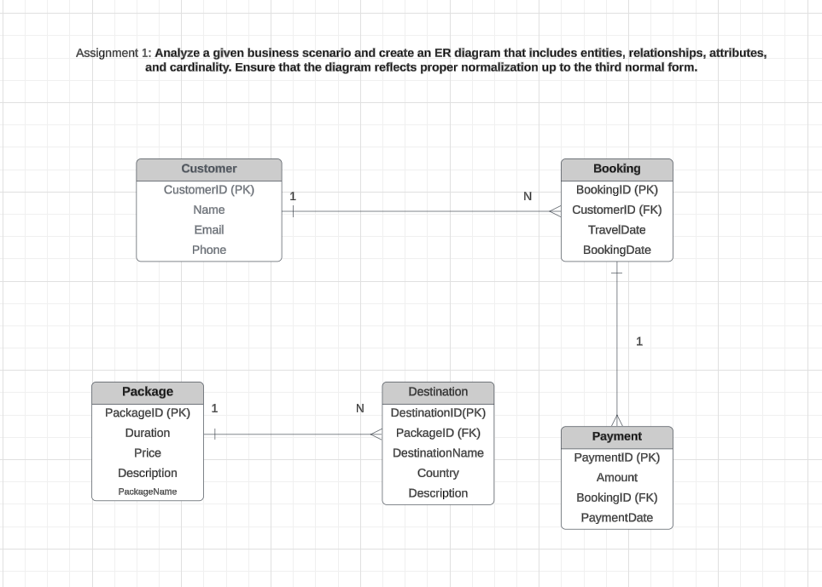

**Luicid work Link: https://lucid.app/lucidchart/aa4ec4aa-090d-4513-b052-6595568e96db/edit?viewport_loc=50%2C-238%2C2444%2C1130%2C0_0&invitationId=inv_c1870cde-90e8-4be2-ab08-90182d858180**